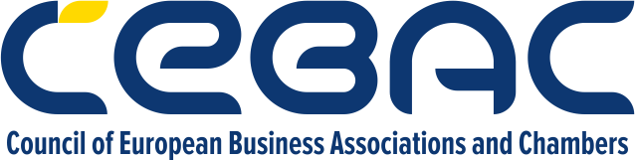

**AGENDA – CBAM WORKSHOP**

**30.10.2025, European House (Evropska kuća),** [**Zmaj Jovina 8**](https://www.google.com/search?rlz=1C1GCEA_enRS1148RS1148&cs=0&sca_esv=bdbe2dd8fffd653b&q=Zmaj+Jovina+8&sa=X&ved=2ahUKEwiT1N7BrqiQAxVd8wIHHbqnAdcQxccNegQIAhAB&mstk=AUtExfDbmY3XP_txn6vBfVtbOUqLxhcosXKYSaYMCJWL8EAB5Otid8mLnDGKAC0VriLPnlpUBzNoZ65DHLmVe8nTACnTmqvIjAQYydzCjXoVS0Ca4ebaGO_95VUkvc4sWotlhWs&csui=3)

9:00 - 9:30, Lower ground floor, Schuman space

**WELCOME PARTICIPANTS**

9:30 - 10:00, Schuman space

**OFFICIAL INAUGURATION CEREMONY**

***Pasquale de Micco****, Head of the European Integration and Economic Section, EU Delegation in Serbia*

***Silvija Rakić****, CEBAC Secretary general*

***Nataša Obradović****, Chair of the ESG committee and Legal Avisor to CFO, Telekom Srbija*

10:00 - 10:20  
**INTRODUCTION**: CBAM Legislation overview

*Filip Živanović, ESG committee co-chair, law office Nikčević Kapor*

10:25 - 11:25

**ROUND TABLE: Companies’ successful practices**

*Participants:* ***Čaba Molnar (Galeb Metal Pack), Dušanka Busić (Milsped), Aleksandar Obradović (ZF), Miroslav Gligorijević (Titan)***

*Moderator: Jovan Babić, Certification manager and ESG committee co-chair (Bureau Veritas)*11:25 - 11:35  
**Q&A**

11:35 - 12:30, Schuman space

**COFFEE & NETWORKING,** *powered by Lavazza*