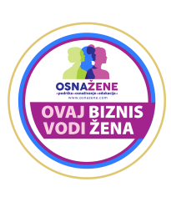

**AGENDA:**

**Promotion of the OsnaŽene Platform and the European Enterprise Promotion Awards (EEPA 2024) First Prize for Serbia**

**THE POWER OF SHE: *From Vision to Impact***

Moderator: Milana Šećerov Hrnjez, architect, designer, entrepreneur, and member of the OsnaŽene platform, (optional)

19:00 – 19:05 | Opening Speech: His Excellency Luca Gori

19:05 – 19:08 Plamena Halačeva, Deputy Head of the EU Delegation to Serbia

19:08 – 19:11 Ms. Maja Gojković, President of the Autonomous Province of Vojvodina

19:11 – 19:14 Ms. Tatjana Macura, Minister without Portfolio in charge of coordinating activities in the areas of gender equality, prevention of violence against women, and the economic and political empowerment of women

19:14 – 19:20 Representative of Confindustria

19:20 – 19:30 Presentation of the OsnaŽene Platform – Dr. Indira Popadić

19:30 – 19:45 Panell Discussion : ***Strategic Partnerships for Women Entrepreneurs***

Moderator: **Milana Hrnjez**

Topics: (Regional Cooperation, Private and Public Sectors, Inclusive Growth, Finance and Technology)

Panelists:

1. Banca Intesa:

2. E commerce Association:

3. UNDP:

19:45 – 19:55 | Presentation of OsnaŽene Members – “One of Us”: Short stories of success and experiences from women entrepreneurs, Members' Testimonials Video

19:45 – 21:00 | Reception / Informal Networking and Refreshments